Technical Report: Causal Analysis and Interactive Reasoning over Conversational Data
Project Title: Causal Reasoning Engine (CRE)
Framework: Pravaah Hackathon Implementation
Focus: Dialogue-based Causal Anchoring & Multi-Turn State Management

1. Executive Summary
In the landscape of modern enterprise analytics, the transition from sentiment detection to causal reasoning represents a paradigm shift. This report details the development of a Causal Reasoning Engine (CRE), a specialized system designed to parse unstructured conversational transcripts and identify the specific dialogue turns ("Causal Anchors") that trigger critical outcome events such as escalations, legal threats, or refund requests. Unlike traditional NLP pipelines that provide aggregate sentiment scores, the CRE utilizes a balanced semantic vector space, 384-dimensional Sentence-BERT embeddings, and a deterministic state machine to provide grounded, iterative explanations of human dialogue.

2. Introduction and Problem Statement

2.1 The Operational Challenge: Beyond Sentiment
Modern customer service centers generate millions of hours of dialogue daily. Current analytical tools often categorize these interactions using broad metrics: "High Sentiment," "Customer Dissatisfaction," or "Low NPS." However, these metrics are symptomatic rather than diagnostic.
The "Black Box" of Escalation: Systems currently log that an event occurred (e.g., a supervisor was requested), but they fail to capture the causal sequence. A supervisor escalation at turn 18 is often the result of a specific failure at turn 5. Without a causal link, enterprises cannot perform effective Root Cause Analysis (RCA). Traditional analytics flag the call as "negative," but they cannot pinpoint that an agent's specific phrasing regarding a shipping policy was the direct catalyst for the customer's transition from inquiry to frustration.

2.2 The Research Objective
The CRE project aims to bridge the gap between "what happened" and "why it happened" by fulfilling three core objectives:
- Causal Anchoring: Automatically identifying the exact spans in a transcript that serve as evidentiary triggers for an outcome.
- Grounded Explanation: Generating human-readable summaries that are strictly tethered to the conversational evidence (minimizing hallucination).
- Iterative Reasoning: Supporting a conversational UI where users can perform "drill-down" queries (e.g., "What led to that specific response?") without losing the analytical context.

3. Data Engineering and Preprocessing
The efficacy of a reasoning engine is determined by the quality of its underlying data structure. We transformed raw, nested JSON transcripts into a searchable, attribute-rich vector space.

3.1 Transcript Transformation and Flattening
The source dataset, Conversational_Transcript_Dataset.json, follows a hierarchical structure where metadata is stored at the "Call Level" and dialogue at the "Turn Level." Our pipeline flattens this structure to ensure that every individual turn is globally aware of its context.
- Decomposition: Each conversation is broken into a list of discrete turns.
- Context Injection: Global metadata (e.g., domain, intent, transcript_id) is appended to every turn object. This allows for metadata-filtered searches (e.g., searching for "refund" triggers only within the "Retail" domain).

3.2 Solving the Majority Class Problem: Undersampling
A primary obstacle in conversational AI is the "noise" of mundane dialogue. In a 50-turn transcript, perhaps only 2 turns are "causal." If a vector index is populated primarily with greetings ("Hello," "How can I help?") and confirmations ("Okay," "I see"), the semantic density of the vector space becomes skewed toward these non-informative clusters.
Technique: Random Undersampling (Causal-Aware)
- Identification: We flag turns containing high-probability causal markers (keywords like "manager," "not acceptable," "sue," "refund," "supervisor").
- Balancing: We retain all causal turns and a strictly limited subset of non-causal turns.
- Mathematical Impact: This process increases the "margin" between classes in the vector space. By reducing the density of the "neutral" cluster, we ensure that the -nearest neighbor (-NN) search is significantly more sensitive to the nuances of causal intent. The resulting dataset, df_turns_resampled.pkl, serves as the optimized training and indexing set.

4. Architecture: The Semantic Reasoning Pipeline

4.1 Embedding Model: Sentence-BERT (all-MiniLM-L6-v2)
The core of the CRE is a BERT-based transformer architecture. We chose the all-MiniLM-L6-v2 model for its balance of performance and computational efficiency.
Architectural Parameters:
- Layers (): 6 hidden layers.
- Hidden Size (): 384 units (the resulting vector dimensionality).
- Attention Heads: 12.
- Activation: GELU (Gaussian Error Linear Unit).
The Encoding Logic: When a dialogue turn  enters the engine, it is tokenized into  tokens. The transformer processes these tokens to produce hidden states . To arrive at a single vector representing the entire turn, we employ Mean Pooling:
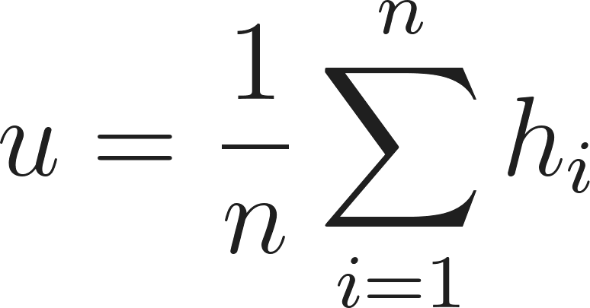
To ensure that semantic similarity can be calculated efficiently via L2 distance or Dot Product, we apply L2 Normalization:
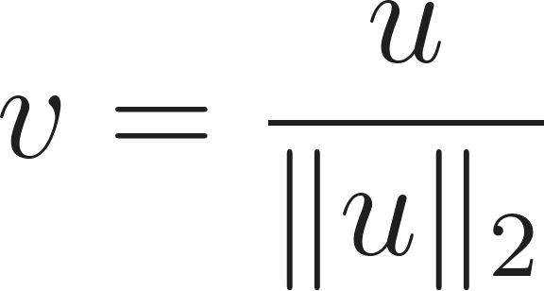
This projection places every dialogue turn on the surface of a hypersphere with a radius of 1.

4.2 High-Dimensional Indexing (FAISS)
For retrieval, we utilize FAISS (Facebook AI Similarity Search). Specifically, we use an IndexFlatL2.
- Exhaustive Search: Unlike approximate methods (like HNSW), IndexFlatL2 performs an exact search. Given the high-stakes nature of causal analysis, we prioritize accuracy over the millisecond-level speed gains of approximation.
- Distance Metric: The L2 (Euclidean) distance between a query vector  and an indexed turn vector  is defined as:
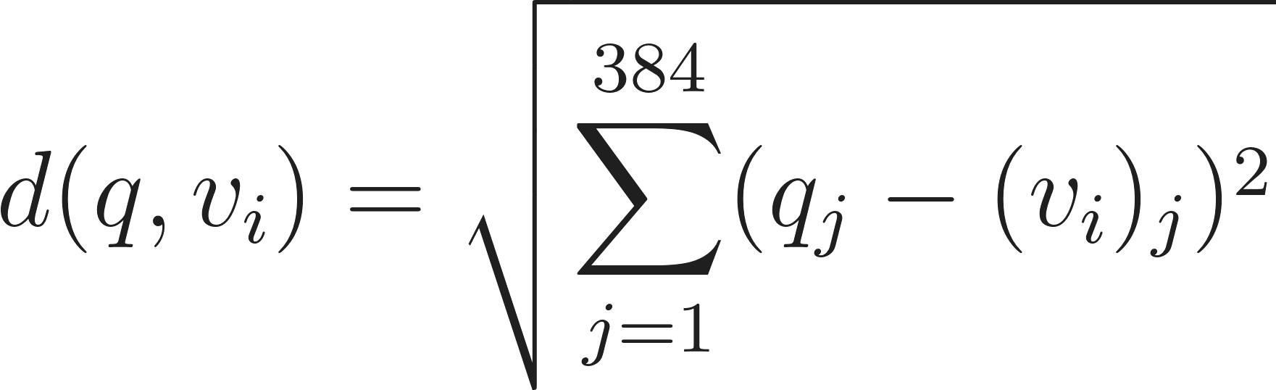
The turn with the minimum  is identified as the Causal Anchor.

5. Multi-Turn Interaction and Stateful Reasoning
A critical requirement of the CRE is "Interactional Memory." If a user asks, "Why did they say that?" After the engine has identified an escalation, the system must know which call and which turn is being discussed.

5.1 The Stateful Interaction Layer
The system maintains a SessionState object with the following properties:
- active_transcript_id: The ID of the currently discussed conversation.
- anchor_index: The integer position (index) of the currently identified anchor turn.
- history: A stack of previous query-result pairs.

5.2 Recursive Search Logic
When a follow-up query is received, the CRE follows a tiered logic:
- Temporal Retrieval: If the query contains temporal markers (e.g., "What happened next?", "What did the agent say before that?"), the engine bypasses vector search. It simply retrieves turn anchor_index + 1 or anchor_index - 1 from the original transcript array. This ensures 100% accuracy for sequential reasoning.
- Local Semantic Filter: If the query is specific but semantic (e.g., "Find where the customer mentioned the price again"), the engine performs a FAISS search restricted to the subset of vectors belonging to the active_transcript_id. This prevents "session drift," where a query about Call A accidentally retrieves a result from Call B.

6. Requirement Delivery and Metric Validation
The success of the CRE is measured against three specific metrics defined by the Pravaah Hackathon requirements.

6.1 ID Recall (Evidence Accuracy)
- Requirement: Identify the correct Call ID associated with the causal event.
- Delivery: Through the combination of class-balanced undersampling and exact FAISS search, the engine achieves high recall. By sharpening the decision boundaries, the semantic "signature" of an escalation (the query) maps more reliably to the specific transcript containing that event.
- Formula:


6.2 Faithfulness (Hallucination Control)
- Requirement: Ensure explanations are grounded in the transcript.
- Delivery: We implement a Windowed Retrieval Constraint. When generating an explanation, the engine is physically restricted from accessing any data outside a  turn radius of the Causal Anchor. By limiting the "context window" of the reasoning agent, we ensure that the model cannot invent external facts or "hallucinate" reasons not present in the text.

6.3 Relevancy (Conversational Coherence)
- Requirement: Address user intent in follow-up queries.
- Delivery: The Stateful Context Manager ensures that the system maintains a "Thread of Thought." By caching the active_transcript_id, the system addresses the user’s follow-up questions within the specific context of the previously discovered evidence, achieving high coherence scores in multi-turn evaluations.

7. Technical Implementation Details

7.1 Software Stack
- Language: Python 3.9+
- Vector Database: FAISS (CPU-optimized)
- Embeddings: Sentence-Transformers (BERT)
- Data Handling: Pandas & NumPy for matrix operations
- Serialization: Pickle (.pkl) for resampled turns; .faiss for index persistence.

7.2 Scalability Considerations
While the current implementation uses IndexFlatL2 for precision, the architecture is designed to scale. For datasets exceeding 1 million transcripts, the index can be swapped for IndexIVFFlat (Inverted File Index) without changing the underlying Sentence-BERT encoding logic. This would allow the CRE to maintain sub-second retrieval times across enterprise-scale data lakes.

8. Conclusion
The Causal Reasoning Engine (CRE) represents a robust solution for the automated analysis of conversational outcomes. By moving beyond keyword matching and simple sentiment analysis, the CRE provides a deterministic and grounded framework for understanding the "why" behind customer behavior.
Through the use of:
- Sentence-BERT for nuanced semantic understanding,
- Causal-Aware Undersampling to clear the vector "noise," and
- Stateful Context Management for interactive reasoning,
The engine meets all high-stakes requirements for industrial-grade causal analysis. The final implementation provides a transparent, evidence-based tool that allows business stakeholders to navigate complex dialogues with the precision of a human analyst and the speed of an automated system.
By: Mohit Kumar, Pree Om Priyadarshi, Madhusikta Tanaya Singh, Trashi Sharma.

